**KPI’s**

1. **Total Revenue**

SELECT SUM(total_price) AS Total_Revenue from pizza_sales

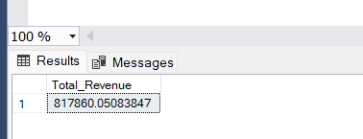

1. **Average order value**

SELECT SUM(total_price)/COUNT (DISTINCT order_id) AS Avg_order_value from pizza_sales

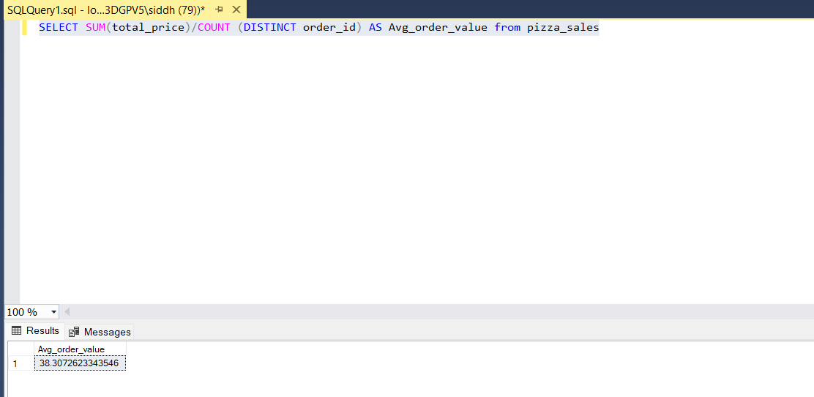

1. **Total pizza sold**

SELECT SUM (quantity) AS Total_pizza_sold from pizza_sales

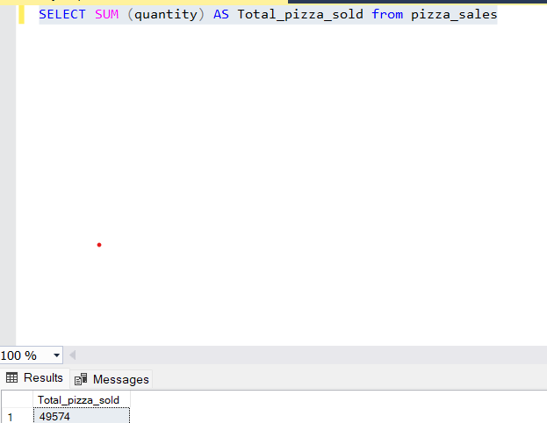

1. **Total order**

SELECT COUNT (DISTINCT order_id) AS Total_order from pizza_sales

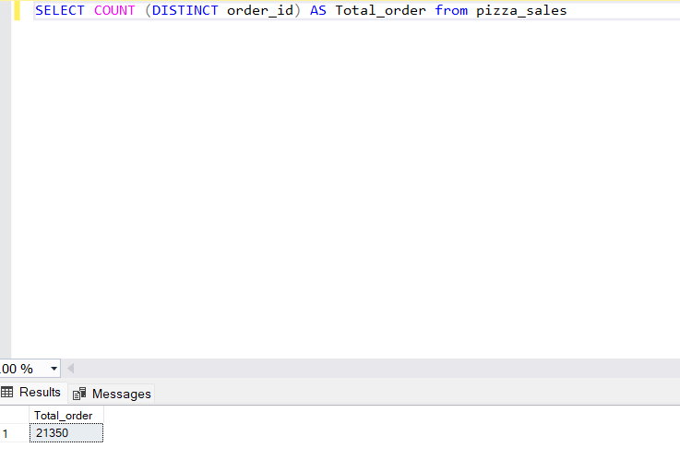

1. **Average pizza per Order-**

SELECT CAST(CAST(SUM (quantity) AS DECIMAL(10,2))/ CAST(COUNT(DISTINCT order_id) AS DECIMAL(10,2)) AS DECIMAL(10,2)) AS Avg_pizza_per_order from pizza_sales

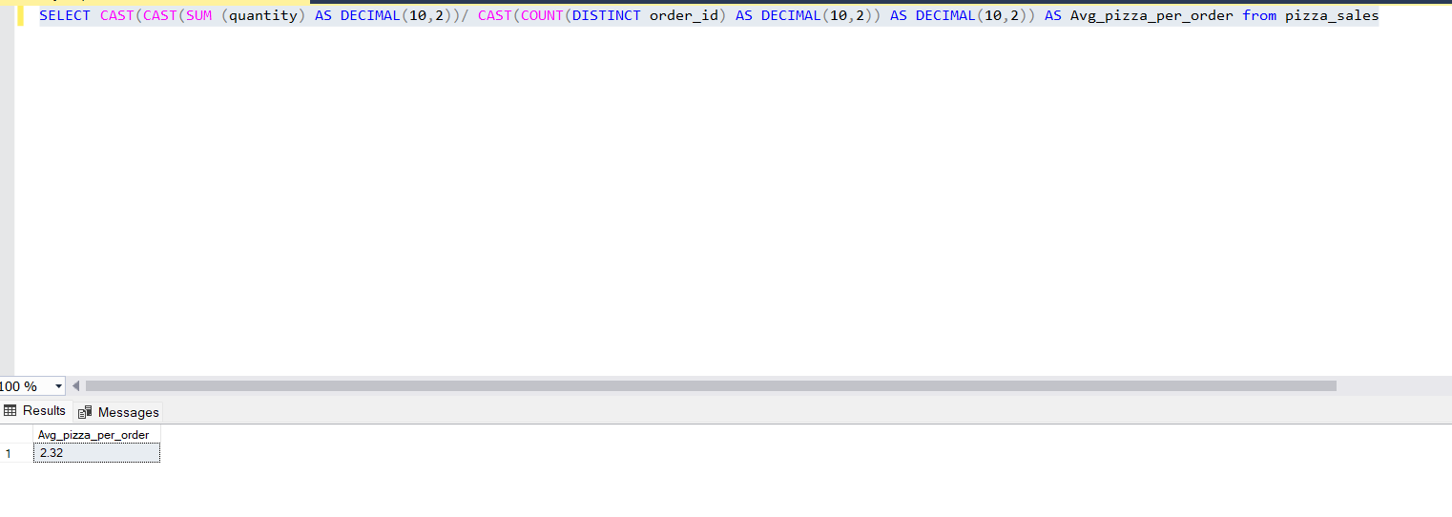

**CHARTS REQUIREMENT**

1. **Daily Trend**

SELECT DATENAME(DW, order_date) as order_day,COUNT(DISTINCT order_id) AS Total_orders

from pizza_sales

GROUP BY DATENAME(DW, order_date )

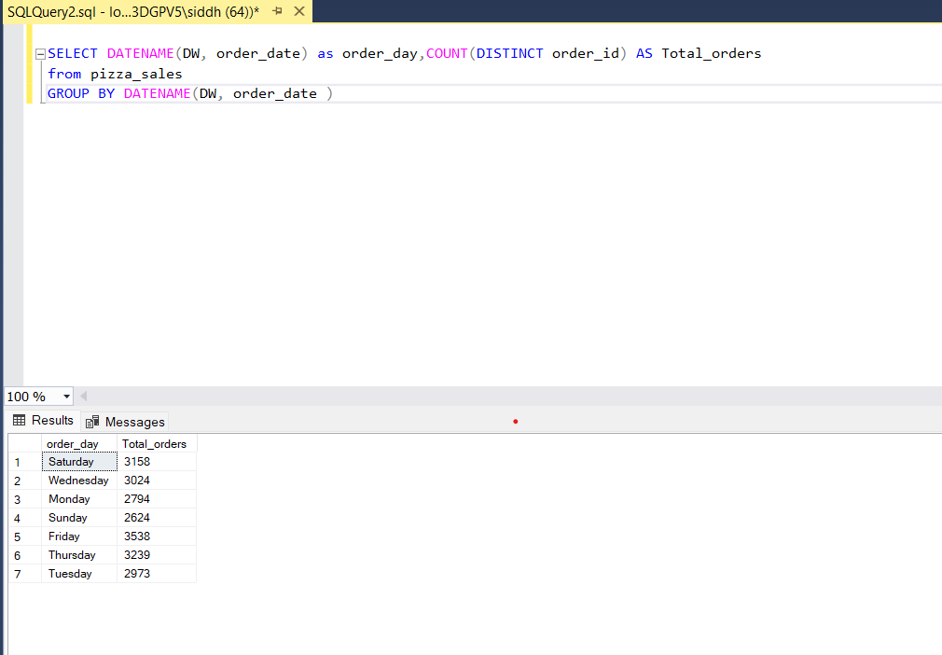

1. HOURLY TREND FOR TOTAL ORDERS

SELECT DATENAME(MONTH, order_date) as MONTH_Name,COUNT(DISTINCT order_id) AS Total_orders

from pizza_sales

GROUP BY DATENAME(MONTH, order_date )

ORDER BY Total_orders DESC

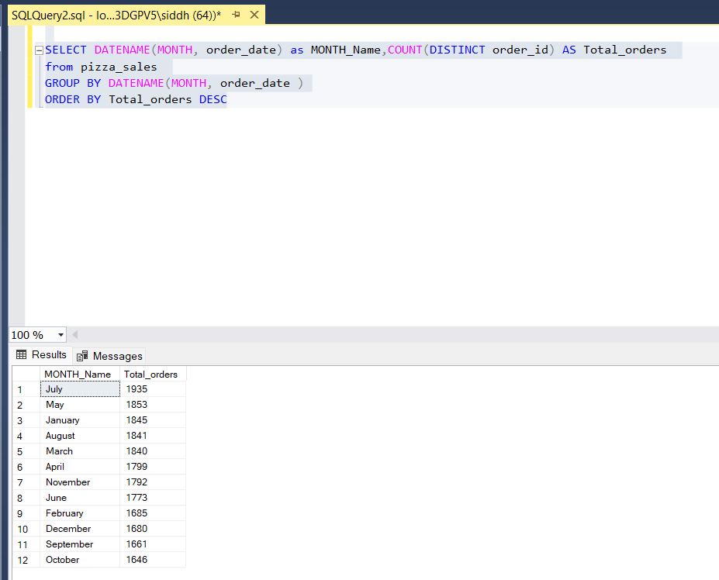

1. PERCENTAGE PF SALES BY PIZZA CATEGORY

SELECT pizza_category,SUM(total_price)*100/(Select SUM(total_price) from pizza_sales ) As PCT from pizza_sales

GROUP BY pizza_category

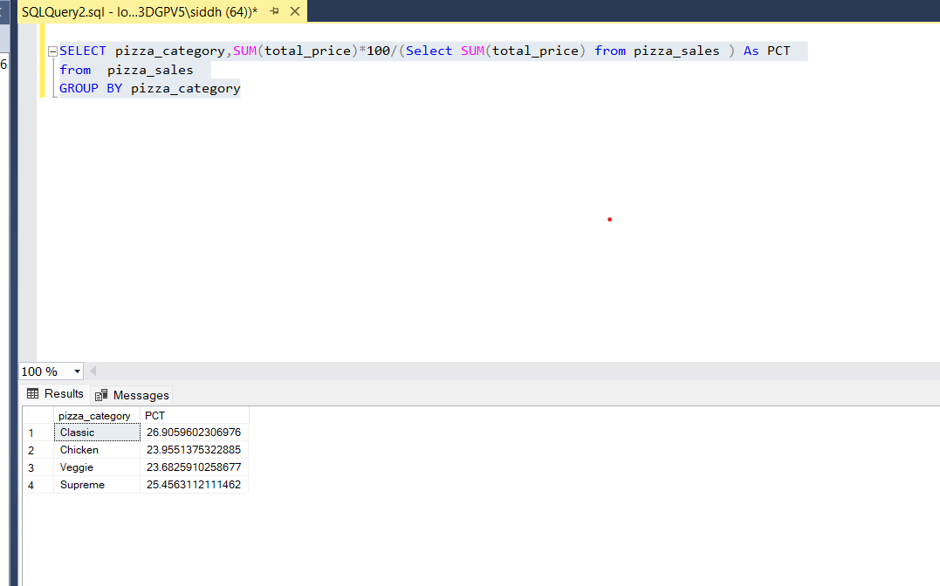

Query for particular month

SELECT pizza_category,SUM(total_price)*100/(Select SUM(total_price) from pizza_sales WHERE MONTH (order_date)=1 ) As PCT

from pizza_sales

WHERE MONTH (order_date)=1

GROUP BY pizza_category

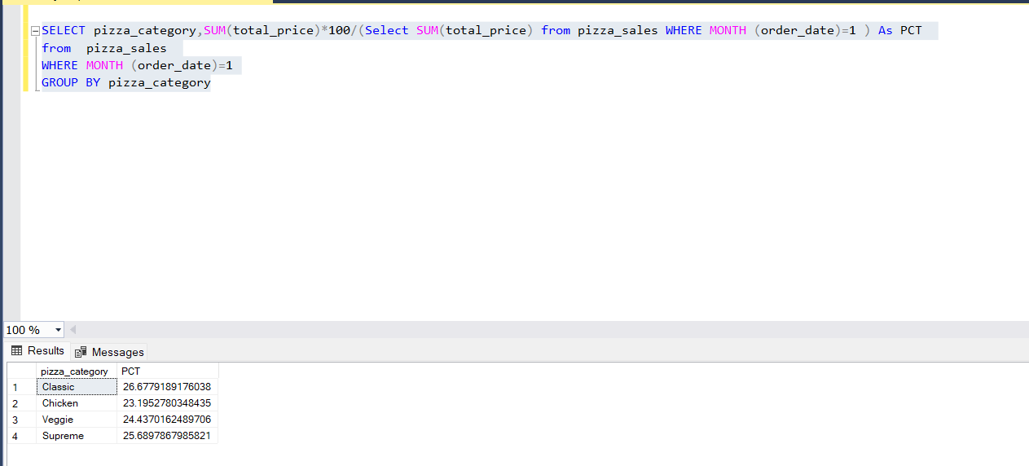

SELECT pizza_size,CAST(SUM(total_price)AS decimal(10,2)) as Total_sales , CAST(SUM(total_price) *100 /(Select SUM (total_price) from pizza_sales ) AS decimal(10,2))

As PCT from pizza_sales

GROUP BY pizza_size

ORDER BY PCT DESC

**By adding quarter**

SELECT pizza_size,CAST(SUM(total_price)AS decimal(10,2)) as Total_sales , CAST(SUM(total_price) *100 /(Select SUM (total_price) from pizza_sales

WHERE DATEPART(QUARTER , order_date)=1) AS decimal(10,2))

As PCT from pizza_sales

WHERE DATEPART(QUARTER , order_date)=1

GROUP BY pizza_size

ORDER BY PCT DESC

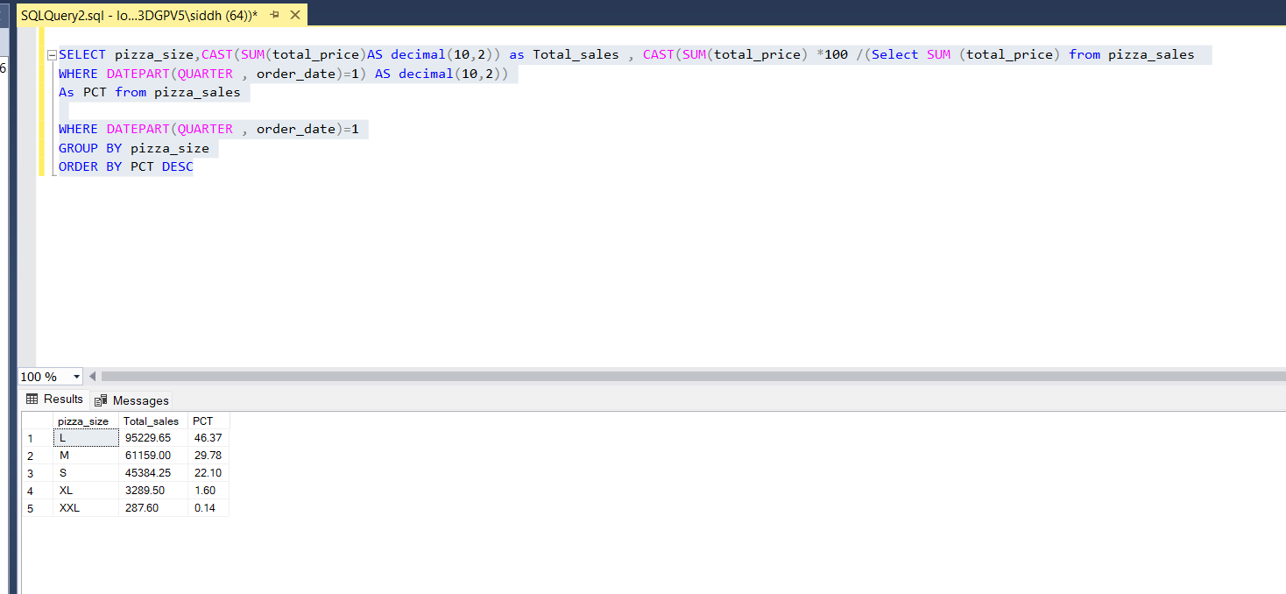

1. Top 5 pizza

SELECT TOP 5 pizza_name, SUM (total_price)AS Total_revenue from pizza_sales

GROUP BY pizza_name

Order BY Total_revenue DESC

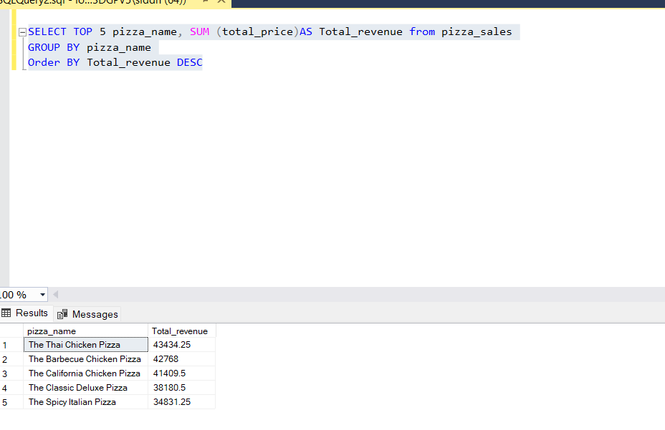

1. Bottom 5 pizza

SELECT TOP 5 pizza_name, SUM (total_price)AS Total_revenue from pizza_sales

GROUP BY pizza_name

Order BY Total_revenue ASC

FOR BY TOTAL Orders

SELECT TOP 5 pizza_name, SUM (DISTINCT order_id)AS Total_Orders from pizza_sales

GROUP BY pizza_name

Order BY Total_Orders DESC

